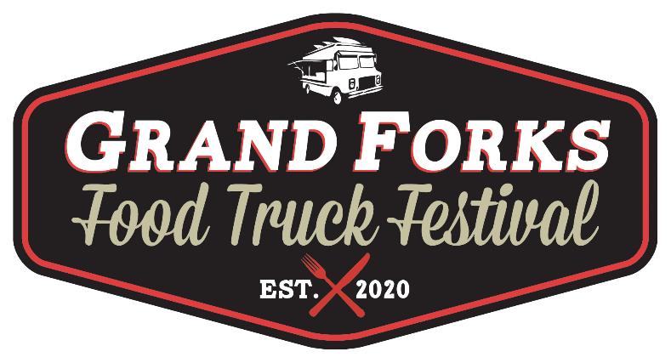

The 2nd annual Grand Forks Food Truck Festival will be held this fall. Location will again be the Grand Cities Mall. We are looking for participating trucks, trailers and carts. Anything mobile eats. This year’s event dates are Fri. August. 27th- Sun. 29th from 11am-9pm Friday 10am-9pm Saturday & 11am-6pm Sunday. Vendors should be on site by 9 am and ready to serve by 11am Friday. We will accommodate any vendor who wishes to set up the night before. We have tons of parking, open areas and many other aspects that will make our event special.
What are we looking for from you? Bring your truck, your crew, and your “A” game. This festival is all about showcasing your “eats”. Truck spaces are $400, (by Mon. , June 28th). Of course, we’ll ask you to promote our event through any social marketing channels and other events that you are participating in this summer/fall. As event promoters, we don’t think there is a better way to promote your truck.
What we’ll provide: a ton of marketing (Printed marketing, radio, social etc.), the venue, security, liability insurance (incidental).
We’d love to hear from you, and we are always open to any ideas that can make this event even more successful. We will continue this annual event and maybe even branch out to other cities in the area. Join us this year and get higher preference for future events.
Thanks for your consideration,

Mike Schmitz
Event Organizer
mikeschmitz@701foodtrucks.com
701-527-7868

Truck Name-

Contact name(s)-

Phone-

Email-

Website or social media page(s)-

Describe your truck/what are your specialties?-

Can you provide us with high quality photos and or logos of your truck/business? (for adding to posters, marketing efforts)- (Yes) (No)

- Email photos to mikeschmitz@701foodtrucks.com

What type of power do you need? 220 or 110 or N/A-

Provide a diagram of your electrical plug-in-

Dimension of your truck? L x W-

What side is your serving window on?-

Please submit your top (8) priority dish offerings. We will work with all truck partners to ensure that nothing is over duplicated.

1.)__________________2.)__________________3.)__________________4.)______________

5.)__________________6.)__________________ 7.)__________________8.)______________

Would you be interested in making a $3 entry for this year’s Sweet Tooth Taste Test? Y/N

Would you be interested in making a special offering for this year’s Makin' Bacon Challenge? Y/N We’ll supply the bacon.

Would you be interested in making a German Themed or beer based dish for this year’s Best of Octoberfest Contest? Y/N

Please note that the consideration of acceptance into this event will be weighted higher with participation of these events. (Preferably at least two)
Food vendors please provide us with the following:
- At least (1) 35 gal. garbage can directly outside of your truck- You are directly responsible for your own area’s cleanup!

- Proof of insurance with 701 Food Trucks & Grand Cities Mall as additionally insured.

- A copy of ND health permit

- A copy of ND tax permit

This year’s event is $400. Payments due along with completed registration. (Late registration add $25- make your registration by Mon. June 28th to avoid late registration fee)

As promoters, the final thing we are asking for is (3) $10 “Gift certificates” redeemable per vendor to be used in our marketing. (On-air radio interviews, etc.) Gift certificates will be produced by the festival and only (3) will be produced for each participating truck.

We will be looking for special room rates at partnering hotel properties to make it a little easier for those of you who are traveling-

Please understand that submitting this application does not in any way guarantee you a spot in this year's event. We won’t cash your check until you are approved. Our selection committee considers many things including: menu offerings, marketability, our previous working relationship, and what you can provide to this year's event.

I understand that as a vendor, sales of water, soda and other drinks are not allowed. Specialty drinks, and drink related vendors will be approved by promoter. Water, soda and alcohol will be served by a licensed event partner.

Please make checks payable to 701 Food Trucks
Address: 213 S. 14th St., Bismarck, ND 58504

Participating Food Vendor 701 Food Truck Festival Representative

Name_______________________ Name_______________________

Signature____________________ Signature____________________

Date________________________ Date________________________

